*Project Proposal*

Remote Metal Detection System

By Jay Wei

12/04/2018

**Instructor**

Prof. Jiang

ENS 491

College of Staten Island

Table of Contents

1. Project Background 2

1.1 Problem Description 2

1.2 Project Objective 2

1.3 Project Specification 2

2.Technical Overview 3

2.1 System Level Block Diagram 3

2.2 System Level Block Description 3

3.Technical Detail 4

3.1 Metal Detection Circuit – LC tank 4

3.2 Metal Detection Circuit – BJT amplifier 5

3.3 Metal Detection Circuit – Simulation 6

3.4 Frequency Receiver and Counter 7

3.5 Software Coding Approach – Frequency Measurement 7

3.6 Software Coding Approach – Object Tracking and Marking 8

4. Project Scheduling 9

5. Cost Analysis – Budget 9

6. Risk Analysis and Mitigation 10

7. Deliverable 10

# Project Background

## Problem Description

Metal detection has always been a crucial part of military technology. As small-scale warfare and terrorist activities escalated, the number of improvised explosive device (IED) attacks has skyrocket. As the naming ‘improvised’ suggests, the IED are cheap, relatively easy to use and accessible to many people.

While metal detection technologies today such as PSS-14 hand-held mine detector are already very sophistical, they required direct human involvement. This is rather dangerous and time consuming.

## Project Objective

The purpose of this project is to develop an integrated metal detection system that allows troop to perform metal detection remotely. This system should consist of a metal detector that can be easily mounted on an RC vehicle which advances in front of the operator and an object tracking software to tag the location of the detected metal.

## Project Specification

* The system shall function properly when metal detector is up 30 feet from the operator
* The metal detector shall have detection depth of up to 10cm below ground
* The metal detector shall be able to detect a metal as small as size of a quarter
* The software shall be able to tag the location of the detector with less than 1 second delay upon actual detection of metal.

# 2.Technical Overview

## System Level Block Diagram

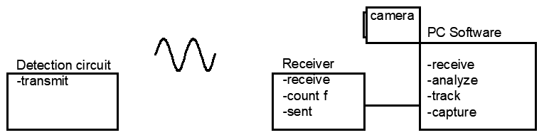

Figure 1. System Level Block Diagram

## 2.2 System Level Block Description

* Detection Circuit utilizes LC tank to continuously transmitting a frequency signal
  + LC tank circuit signal to be amplified by BJT amplifier (Colpitts Oscillator)
  + Signal transmitted via a 433mHz carrier frequency
* Signal frequency to be received and measured by an remote receiver and send data to PC
  + Received signal through 433mHz receiver module
  + Frequency count by Arduino
  + Data sent via serial communication port
* Software to analyze frequency data, track detector from camera, and capture image.
  + Python as programming language
  + OpenCV as main library
  + Background subtraction technique for object tracking

# 3.Technical Detail

## Metal Detection Circuit – LC tank

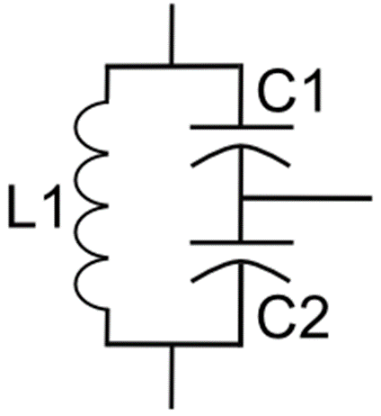

Figure 2. Typical LC tank circuit

* LC tank circuit operates in such way that when current discharged from the serial capacitors flows through the indicator, when the capacitors are fully discharged, the inductor begin to discharge to maintain the current flow thus charging the capacitor. Process repeats results in oscillation
* 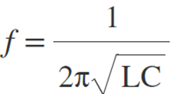 Eq(1)
* Frequency generated by LC tank circuit inversely proportional to L and C.
* Inductance varies as inductor approach metal object based on below equation
* 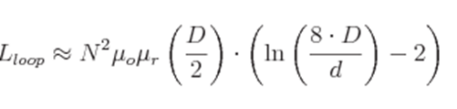 Eq(2)
* Assume we use 24AWG wired 50 turns around a 10cm loop as our detection coil, the L would be 0.8±mH, and each capacitor is 0.1uF
* Frequency = 1 / (2*pi*sqrt(0.8E-3*0.05E-6)) = 25kHz
* 25kHz is our base frequency, meaning no metal is detected.
* Therefore, the goal is to detect the change in frequency.

## Metal Detection Circuit – BJT amplifier

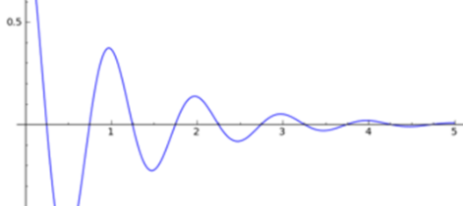

* In real life, oscillation of LC circuit dies out instantaneously
* 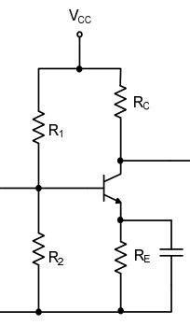Add BJT amplifier to continuously add gain to the oscillation

Figure 3.Common Emitter Amplifier

* The combination of BJT amplifier and LC tank becomes a Colpitts oscillator.
* According to *Colpitts Oscillator Design* published by *petervis.com,* for the oscillator to start, the voltage gain must be greater than C2/C1 of the LC tank. Since we chose C1 and C2 to be the same, the voltage gain shall be > 1.
* Approach this by design a Common emitter amplifier with voltage gain of 5.

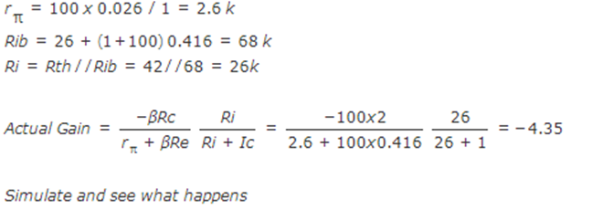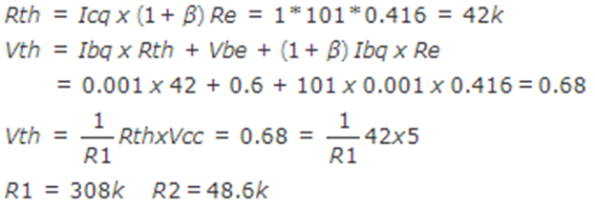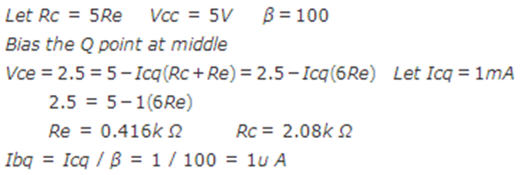 Calculation:

* So let Rc = 400Ω , Re = 2000Ω, R1 = 310kΩ and R2 =49kΩ

## Metal Detection Circuit – Simulation

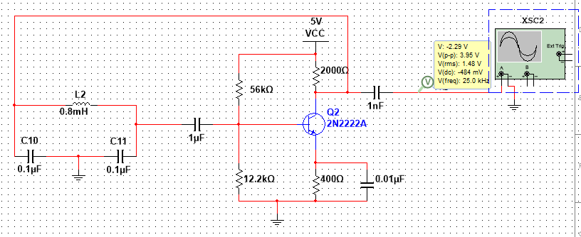

Figure 4 Circuit Simulation

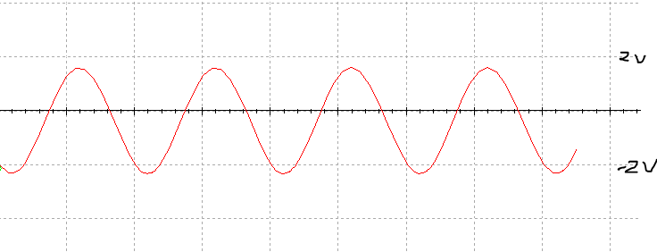

Figure 5 Output Signal

* Signal to be sent thought 433mHz carrier frequency using manufactured module.

## Frequency Receiver and Counter

Figure 6 Receiver and frequency counter

* Signal to be received by RF receiver module.
* DC bias added to make the signal digitally measurable by Arduino digital pin.
* Amount of DC biasing to be determined based on actual received signal

## Software Coding Approach – Frequency Measurement

* Arduino UNO ATMega328 microcontroller equipped with 3 timer/counter registers (TCCR)
* TCCR can be configured to received external clock source which can be our signal
* To count the frequency, Output Comparison register (OCR) can be configured to decrement by 1 every clock cycle (cycle of our signal).
* Then by measuring the time interval between each time the OCR reaches 0, we can calculate the frequency by dividing max number in OCR (255 for 8 bit) by time interval.
* FrequencyCounter library

## Software Coding Approach – Object Tracking and Marking

* The goal is to track the metal detector on a camera and mark its location accordingly
* To trigger the marking of the detector’s current location, we set a threshold for the frequency. When frequency reach out of the threshold, the location of the detector at that specific moment is captured.
* Object Tracking using Background Subtraction Concept
  + In computer vision, image/frame is represented by matrix (size to be determined by pixels).
  + Each element of matrix hold (3) 8 bit values (0-255) each represents Red, Green , Blue. ie (255,255,255) represent pure white.
  + Computer first capture frame1 as background, and then frame2 with object is captured.
  + Subtracting Frame2 by Frame1 will produce a Difference-Frame
  + Difference-Frame holds the information about the location of the object
  + By continuously subtracting new frame by frame1 as camera is recoding, object can be tracked
* OpenCV library

# 4. Project Scheduling

# 5. Cost Analysis – Budget

Estimation based on pricing from AMAZON

Major purchases:

1. Arduino UNO R3 18.90
2. 433 mhz transmitter and receiver 5.00
3. 197’ 24AWG magnet wire 7.45

Minor purchases:

Resistor, Capacitor, Transistor, AA battery 10.00

Total 41.35

# 6. Risk Analysis and Mitigation

* One major assumption made to this project is that the rf transmitter will successfully carry the base signal, and the receiver will receive the actual signal that is generated by oscillator without major deviation.
* The signal received by receiver will not be exactly the same as the signal transmitted.
* However, adjustment to circuit and program can be made to adopt the deviation.
* If the deviation is too severe, then it might be more practical to measure the frequency at the detection side using additional microcontroller and transmit only frequency value.

# 7. Deliverable

* Upon completion of project, live demo will be given in the class.
* A completed project will consist of
  + (1) metal detector with transmitter
  + (1) Arduino with receiver circuit (+ frequency counter program)
  + (1) Laptop connected to Arduino (+ object tracking program via webCam)
* A successfully project will produce the resulting image with tags indicate where the detector detect metal.

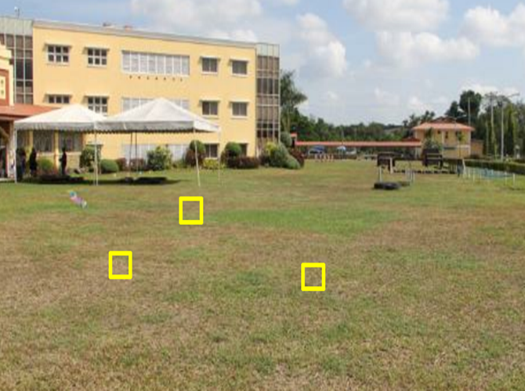

Figure 7 Example of expected result